**Data Types in Python**

The built-in data types in Python are displayed below.

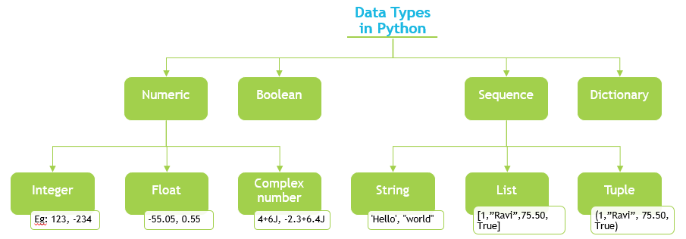

|  |  |  |
| --- | --- | --- |
| Numeric |  | Any representation of data which has numeric value. Python identifies three types of numbers – integer, float and complex number. |
|  | Integer | Positive and negative whole numbers.  Examples: 1234, -234, 0x46 (hexadecimal number), 0O123 (octal number))  Note: In C and related programming languages such as Python, a hexadecimal number is prefixed with 0x and an octal number is prefixed with 0O. |
| Float | Real numbers with a floating point representation in which the fractional component is denoted by a decimal or scientific notation  Examples: -55.550, 0.005, 1.32E10 (scientific notation)) |
| Complex number | A number with a real and imaginary component is represented as a + bj inPython where a and b are floats and  j = √-1  Examples: 4+6j, -2.3+6.4j  Note: The common mathematical representation of a complex number uses a +bi with i being the imaginary part. But in electronics j is used because i already represent current and the next letter after i is j. |
| Boolean |  | Any representation of data which has two values denoted by True and False. |
| Sequence |  | An ordered collection of similar or different data types. The built-in Sequence data types in Python are – String, List and Tuple. |
|  | String | A collection of one or more characters put in single, double or triple quotes.  Examples: ‘Hello’, "Hello", "'Hello'", """Hello""" |
|  | List | An ordered collection of one or more data items, not necessarily of same type, put in square brackets.  Examples:  [1,"Ravi",75.50, True] |
|  | Tuple | An ordered collection of one or more data items, not necessarily of same type put in parentheses. The contents of a tuple cannot be modified – it is immutable - after the tuple is created.  Examples: (1,"Ravi", 75.50, True)  Note: Refer to the Helper Text to learn more about mutability. |
| Dictionary |  | An unordered collection of data in key:value pair form. Collection of such pairs is enclosed in curly brackets.  Example:  {1:"Superman", 2:"Wonder Woman", 3:"Thor", 4: "Hulk", 5:"Black Widow"} |